*Voxel Party (pendent)*

Pedro Veras

Similar to Mario Party

Series of mini-games for 1 to 4 players

Players choose characters and rules at the start

Players can customize their characters

Character controls: Move, jump, dash, punch and grab weapon

Top down view

Toogle on/off minigames

Minigames:

Each minigame awards the winner player a medal.

There are minigames where the players all play together or play separetely

* Versus (spelunky, duck game) 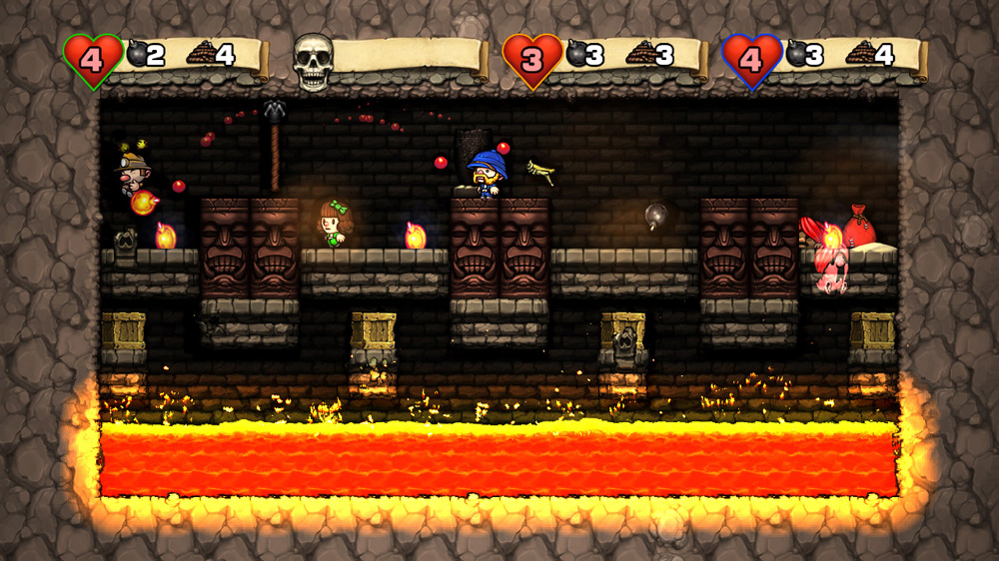

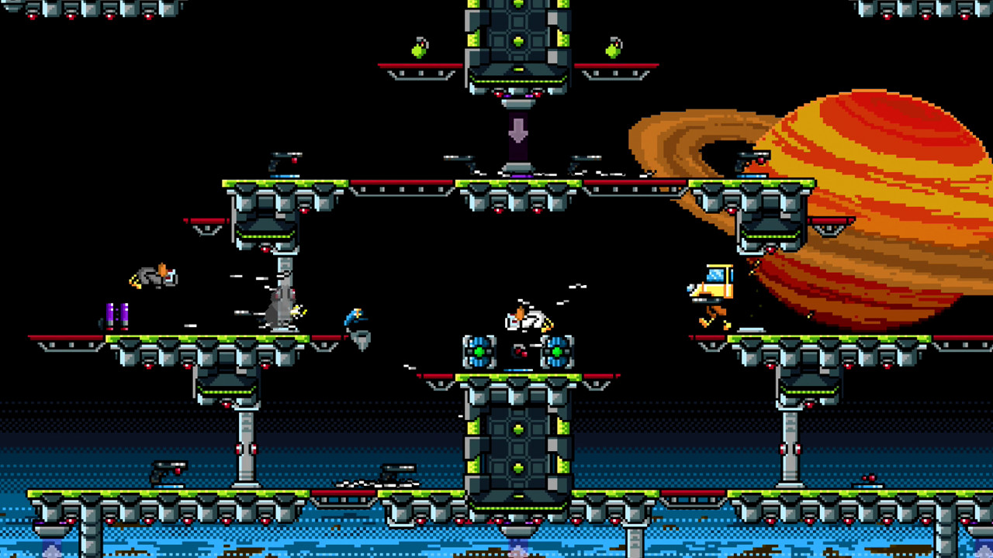

Player grab weapons and try to defeat each other. Last on remaininng win

* The floor is lava

All players begin on a plataform. Lava starts rising and player need to get to the top to win

* Push player of platforms

Similar to versus buut players can only win if the knock others of off the plataform

* Race

Player race to a spot. Each player is in a diferent track (the tracks all have the same layout). Firt one to the end wins

* Collect the most points

Player need to collect the most points until time runs out

* Survive the longest against balls

Balls of energy shoot in various drections and players need to avoid them

* Open boxes to get a weapon

Multiple boxes with a single cannon. Players must open boxes to get the cannon and defeat other players. Cannon has timer once picked up. When the cannon disapears, boxes respawn and the game continues

* Genius

Player are located on 3x3 grid that falls periodically. Blocks that fall blink before they fall

* Spot the diference

4 images show up on screen and players must find the diferent one